JAVA ASSIGNMENT

CONSTRUCTORS

*Submitted by,*

TAMILVANAN B.

2018503566.

MO BATCH.

**Create a simple java program for library application that will demonstrate the usage of constructors in it. Note:  include no arg constructor ,parametrized constructor, copy constructor, constructor chaining.You can use any number of instance variable and method,**

Program:

class Library{

String book;

String author;

Library(){

this("The Holy Bible");

}

Library (String bk){

this("The Holy Bible","James King");

}

Library(String bk,String at){

book = bk;

author = at;

}

Library(Library obj){

System.out.println("Copy constructor: " + obj.book + ": " + obj.author);

}

}

public class Two{

public static void main(String... args) {

Library lib1 = new Library();

lib1.book = "Quran";

lib1.author = "Muhammad";

System.out.println(lib1.book + ": " + lib1.author);

Library lib3 = new Library("Bhagavad gita","‎Vyasa");

System.out.println(lib3.book + ": " +lib3.author);

Library lib4 = new Library();

System.out.println(lib4.book + ": " + lib4.author);

Library lib2 = new Library(lib3);

}

}

Output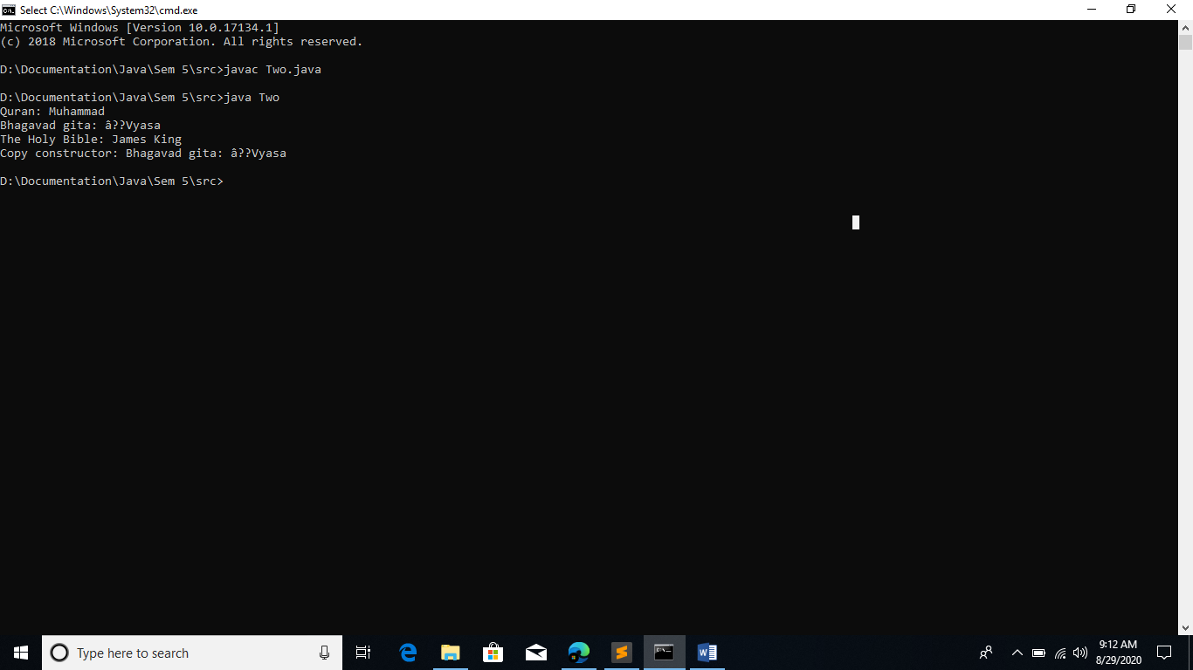

In this the order of execution is that this() method with one argument will search for a constructor with one parameterized argument and in that constructor there is a this() method with 2 arguments this will search for a constructor with 2 parameterized arguments.